Halloween Haunt
At ValleyScare!
Saturday, Oct. 5, 2019
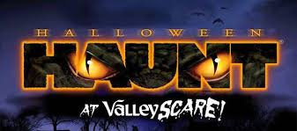
High School and Middle School students, come join us for an evening of fun at ValleyScare on Saturday, October 6. Bus departs from the Church parking lot at 3:15 p.m. and returns at 11:45 p.m.
----------------------------------------------------------------------------------------------------------------------------------------
ValleyScare Order Form
Saturday, October 5, 2019

Name__________________________________

Phone Number__________________________

Email __________________________________

Number of Admissions Tickets at $20 each __________ X $20 = ___________
Note – ValleyFair season ticket holders – NO COST

Number of people riding the bus at $5 each __________ X $5 = ___________

Total Due ___________

Make checks payable to Church of St. Dominic.

Note: Complete a permission slip for each student riding the bus.

